**Self Check**

**根据短文内容，从方框中选择恰当的单词填空，注意形式变化，每词限用一次。**

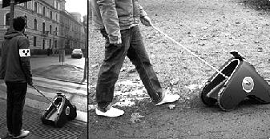

|  |
| --- |
| comfortable, cheap, choose, try, talent, poor, easy, example, role, pretty |

There are a large number of blind and visually impaired people (盲人和视力受损的人) in the world. They have different (1)_______ just like us normal (正常的) people. They also want to do many things and live as (2)_______ as us, but they can't see! They need someone or something, for (3)_______, guide dogs, to guide their way. However, many of them are still very (4)_______ and live a hard life, so they don't have enough money to buy a guide dog.

As we all know, training a guide dog is (5)_______ expensive and it also needs a lot of time, so they can't get one (6)_______. What will happen if there are some robots to guide them? I think their life will be much (7)_______. Luckily, scientists (科学家) are now (8)_______ hard to make such kind of guide robots.

In the future (未来), there are sure to be many guide robots. Those robots will play an important (9)_______ in making their lives much better. What's more, those robots will be cheap enough for each of them to (10)_______ one from many different kinds. When this happens, I'm sure it will make their lives much happier.

**参考答案**

1. talents  2. comfortably  3. example  4. poor  5. pretty

6. cheaply  7. easier  8. trying  9. role  10. choose